*Interdisciplinary Themes Journal* 2.1 (2010). © Hisham Elshimy . Readers of this article may copy it without the copyright owner‟s permission if the author and publisher are acknowledged in the copy and the copy is used for educational, not-for-profit purposes.

**MEASURING THE ECONOMICAL IMPACT TO THE SUSTAINABLE DEVELOPMENT OF ARCHITECTURAL HERITAGE AREA IN METROPOLIS A PILOT STUDY FOR DEVLOPING PRACTICAL ELMOAZ STREET, FATIMIC AREA ,CAIRO**

**Hisham Elshimy** *University of Pharos in Alexandria*

**ABSTRACT**:

The importance of this study, is planning studies to address the analytical areas of architectural heritage with take into account the dimension of the economic side  and a common link is restricted to return to the utilitarian perspective of economic development as a specific evaluative Standard and the main purpose of the study is to reach a matrix to measure the economic returns to the development of areas of architectural heritage as an input to the scheme of development of the Metropolis who has a pilot study of the study area.  
The aims, parallel with the purpose of the study , are concentrated in defining the future framework for the development of aspects of urban heritage development as part of the city's Islamic and highlight the economic output of the Architectural Heritage. The methodology on the study is the systematic nature, ranging through the stages of research seemed to view the inductive phase of the foundations of planning and development mechanisms for regions Architectural Heritage Phase inferring through prioritization planning, and focus on the economic dimension as a parameter of the major graphic developmental studies, and phase is applied through the study of the analysis program to measure the economic impact  and expected Conclusions  that can be out of this reach , the architectural heritage areas are important element can make use in the development of economic resources of the hinterland of the Metropolis and that the economic impacts of a specific development plans **KEYWORDS**: Urban economy - development - city planning - Architectural Heritage - Street Almoaz Fatimid - Cairo.

**INTRODUCTION:**   
Egypt is one of the oldest civilizations in the world and the richest areas of cultural heritage and most diverse on earth. Although many of these effects may have disappeared because of natural disasters and is an integral part of the physical links with our history and values that we hold dear.   
Egypt is the gift of the Nile, and there is probably no other country in the world have such a gift of the Nile River and is a life spin   
Cairo's architectural landmarks in the ranks of humanity and great achievements, to recognize that maintaining them is a matter of importance to the whole world and included Egypt in the UNESCO list of heritage as one of the distinctive historic architectural treasures ( Ministry of Culture, 2002 )   
Therefore, it must develop a plan to manage the historic district with a five-year vision for the future, at least as a plan and an affirmation of values, emotional, cultural, social and economic located in cultural property and an explanation of these values depending on the priorities   
Site Heritage message must be respected and preserved, as well as identifying sources of funding necessary for development through the planning process, program development, budget preparation in a practical package and must be continuously reviewed to correspond with the plan and method of work and identify maintenance programs and the duties and responsibilities of your maintenance  
( Ministry of Culture, 2002 )

**Research Objectives:**   
 Determine the future framework for the development of aspects of urban heritage tourism development as part of the Islamic city and increase economic impacts of the Architectural Heritage, including developing the social conditions and increasing job opportunities, and organizing efforts among relevant actors helping to form a professional team to manage the system development zones architectural heritage   
Research hypothesis:   
Areas of architectural heritage is a rich regions need to respond to the effective development of tourism-yielding outstanding economic and sustainable planning of activities and uses as one reaches the main access to the sustainable development of the areas of architectural heritage nature tourism in the city, so is the nucleus of the sustainable development of the city, the mother and through the empirical study we find that the Almoaz street nucleus the sustainable development of historic Cairo as part of the development of Cairo Governorate  
**Methodology:** The general methodology of the research: -   
Adopt the methodology of the research on the combination of inductive and deductive approach and analytical in sequential   
1 - deductive and inductive approach: -   
Through a review of the concept of heritage areas and mechanisms for dealing with them and develop the strengths and weaknesses of the   
2 - analytical method: -   
Analyze the economic effects of direct and indirect resulting from the sustainable development of areas of heritage nature tourism in the city   
3 - Field approach: -   
A Field Study of Almoaz street to study the economic returns resulting from the development project and port development in the region  
1 - traditional areas of the city (website coordinating body of civilization in Egypt , 2010)   
are areas of distinctive residential character of the historic and architecturally, both originated in ancient times, different ancients Coptic and Islamic, or those that arose during the nineteenth century and early twentieth century. According to Law No. 119 of 2006 - the item coordination of civilization and its executive regulations, these areas are characterized by an element or more of the elements specified by the traditional criteria for determining the areas referred to regulation.   
Therefore, the areas of heritage value and its surroundings must be considered including the whole of the

buildings, squares and parks and streets, are a group integral depends on the balance between the parts of the nature and consistency of components and represents the type of use and activities are made an integral part of the architectural heritage along with the architectural heritage and therefore the kinds of trade and crafts and industries are an important part of the traditional and social considerations, which needs to be preserved and strengthened in the traditional areas in accordance with international conventions in maintaining the architectural heritage The concept of archeological sites is referred to areas that have been registered in accordance with the Law of the effects and would therefore be subject to the effects of methods of protection and organization of building heights around the campus and determine the impact, and other requirements for the protection of monuments in the law. It Can be applied to requirements for areas to areas of archaeological heritage, particularly with respect to a sphere of heritage buildings and protective factors such as determining elevations to conform with the heritage buildings or to identify activities that are compatible with the nature and characteristics of areas and heritage buildings. Often, the areas heritage in space archaeological sites as a group of heritage buildings housing dating back to the nineteenth century and early twentieth century, which is located on the effects recorded in the historical sites in Cairo and in this case to be considered as such areas as heritage distinct and need to be registered and maintain appropriate methods renovated or rehabilitated so as not to be demolished or altered in losing worth.  
**1-1 criteria for determining areas of heritage value**   
 Identify areas according to traditional history and characteristics of the region and also build on the presence of clusters of heritage buildings in these areas. Areas include the traditional areas of the entire area Downtown (Cairo Alkadyai), or the Turkish quarter of the European quarter in Alexandria or specific locations within the region or district, according to the quality of planning and features of architectural or according to the intensity of heritage buildings, and can also be considered a field or an entire street as a heritage unique, whether within the conservation area or outside the executive regulations of Law No. 119 of 2008.   
It must take these areas a priority and special attention for environmental issues and public landscaping and pavement infrastructure is the most important areas that characterize the city and highlight the glory and beauty and value.   
By dealing with the heritage areas through the following steps:   
A - Identification, documentation and registration   
B - Classification and prioritization   
C - a regulation on the protection and preservation   
D - Implementation of Conservation Projects **1-2 The mechanism to identify and record the traditional areas:**   
 By determining the scope of heritage areas on the maps of the reality of historical maps, according to the importance of heritage buildings. Applying the principles and criteria contained the executive regulations of Law 119 of 2008, and are documented areas of traditional excellence in order to take action to maintain and protect the necessary and the application of building regulations and urban planning and coordination of civilization of their own, where you must work archive special attention to these areas in each governorate and record the areas heritage After you select the ranges , it is set in the comprehensive outline of the city as areas of heritage and of great value, then it is a special scheme suited to character, and distinctiveness. And notify the city councils and local councils and Private Associations ( NGOs) in this register to be taking the necessary action to protect and preserve and develop plans appropriate according to the nature and characteristics of each region separately Archive contains the following elements:   
a - Maps, charts, original historical and current standards of different drawing and aerial photographs that highlight various characteristics of the planning and construction of the region  
b - Historical documents on the establishment of a city or region and its development, Historical Maps, which describes the developments that took place in the area.   
c - Laws and regulations on the organization of the region and ways of their construction (as a villa or at the responses from the street - or to determine altitude and view the roads, landscaping ... etc.).   
d - Studies and research conducted on the region or city, which is conducive to show their properties. **1-3 Category areas of heritage:**   
 It can be classified as an entire city or district or field or street or part of the area or heritage value. It does not mean that freezing because the region should enjoy the traditional life and activity in the framework classified into three levels according to the priorities of protection required as follows:   
Area of heritage value or the level of (a): maximum protection zone   
Area of heritage value or the level of (b): medium-protection zone   
Area of heritage value or level (c) a transition zone between the regions of protection (maximum / medium) and normal   
**1-4 documentation and recording of areas of value:** The national system for coordination of civilization to identify areas of value-traditional or unique may be the assistance of the Standing Committees, the relevant inventory of buildings in the governorates sign areas on the survey maps include the general outline of the city, then flying to the Supreme Council for Planning and Development, chaired by the Prime Minister for approval.   
**1-5 reasons for the deterioration of the traditional areas of Egyptian cities:**   
 Because of absence of a plan to preserve the heritage areas of Egyptian cities and protecting them from degradation and urban sprawl, has led to these areas exposed to heavy damage from the destruction and degradation of the demolition of many heritage buildings, the task on local and global levels. One example is what has happened in the Cairo area, the record UNESCO World Heritage site, and the "Cairo Alkadyai" known as the central district of the country, and Garden City, as well as what has happened in the city of Alexandria, a deterioration of the beards of the Turkish and the demolition of large parts of it, also the deterioration of buildings in downtown Alexandria and the district known as the European. As well as the deterioration of the historic nucleus of Rashid where the demolition of many historic buildings and heritage, becoming the remaining historic homes scattered and unrelated and the old urban fabric, which represents the heart of the city, and thereby destroy the most important features of the city of Rashid and lost some of its cultural value and return on tangible property in the development of tourism.   
In spite of these negative phenomena, it is still much can be achieved to save the lives of the living heritage in the cities of Egypt, through the preparation of development plans, maintenance and repair of buildings, heritage and the remaining rebuilding neighborhoods and streets heritage in some special cases, as in many cities of Europe, particularly Germany Poland, which had previously been destroyed during World War II, and then re-building their buildings and streets, which had a return civilized important, and a flourishing tourism.   
**2 - foundations of planning and development mechanisms for areas of the architectural heritage** (website of the Coordinating Body of civilization (2010), Egypt)   
 The range planning basis for the development of urban heritage areas depending on the nature of urban and architectural heritage of the area and location for the city and depending on the trends of development and thus vary the mechanisms used to hoping zones architectural heritage   
**2-1 planning basis for the development of areas of the Architectural Heritage** T his step contains several items: 2-1-1 The signing of the region borders and physical features on maps, including the distinctive markings within the residential area and the tracks and the entrance to the area and the assembly points.   
2-1-2 study the historical development of the region and identify privacy, giving indications of nature, cultural, economic and physical indicators also given the trends of growth and the factors that threaten heritage  
2-1-3 The signing of heritage buildings on the map of the region, according to the classification of A, B, C and be done after the adoption of the committees of the provinces after a comprehensive survey of the buildings and heritage recording, and then determine its relationship with the outline and assess the role of historic buildings there.   
2-1-4 By conducting the necessary studies related to social aspects, which describes the economic activity of the inhabitants of the region and the level of income and educational status, as well as studies related to activities such as traditional handicrafts.   
2-1-5 The zoning and commercial hubs in the region to work to find a balance between nature and the needs of residential areas and commercial areas schema uses to prioritize the needs of the services.   
2-1-6 determine the percentage and the size of buildings in relation to the Earth's land surface, taking into account the rules of organization of each region to determine the regulations for new buildings within the heritage area **2-2 mechanisms of development zones architectural heritage ( Website of the coordinating body of civilization (2010), Egypt)**  This step contains several items:   
2-2-1 the preservation and rehabilitation of heritage buildings and is considered among the most important factors that protect the areas heritage.   
2-2-2 protect the urban fabric of the Land Subdivision and the network of streets.   
2-2-3 maintain the components of the region and their environmental characteristics of natural Satie rivers or human-induced such as parks, public. 2-2-4 Respect the historic street fairs to maintain the urban fabric. May not open new streets or expansion of existing streets leading to the demolition of heritage buildings existing in violation of the principle of preserving the architectural heritage and urban  
2-2-5 conceptualizing urban cross-traffic arteries and the possibilities of dealing with vacant land with potential for the design of these places and cordons urban and improve their performance, depending on the determinants of planning and urban design for the region and the role played by the city and the mutual relations with other regions to study the potential for meeting the requirements of population and strengthen economic activities appropriate to the nature of the heritage of the region.  
2-2-6 study to improve traffic and pedestrians and the possibility of one-way to traffic on narrow roads or to prevent the wait. Can also prevent the passage of cars on the streets of displaying at least 4 meters with only allowing the passage of cars and ambulance Fire Station, with the intervention to facilitate the passage open some streets to vehicles or pedestrians to facilitate the support of urban development areas of old. And be narrowly to avoid a damage to the historic nature of the areas, to undertake this business experts in the field of architectural heritage.   
2-2-7 development of architectural parameters for new buildings or buildings being reconstructed in the region - to discuss the protection and preservation plan with the executive and the local community and development of operational plans.   
**2-3 mechanisms to implement conservation projects for the urban areas of the Architectural Heritage** The problems faced by projects require architectural conservation projects to guiding as a Pilot Project in the early stages depending on the situation in the region and vary parameters and provide information and data with the function of the following: 2-3-1By restoration or rehabilitation of a group of buildings to identify the best methods to complete projects to maintain the entire region   
2-3-2 By convince the residents and owners the feasibility of the project, which supports confidence based on the project.   
2-3-3 By identify the strengths and weaknesses in the project to be developed later 2-3-4 The personnel training required in this area to work on a larger scale.   
2-3-5 By demonstration projects under the watchful eyes of specialists and experts during the stages of preparation, design and implementation.   
As for the 2-3-6 By implementation at a large scale like sector or city is divided the region into smaller regions or to groups of buildings are treated the same way as the pilot project. It can be business as well as the level of the region according to specialties, such as consolidation of first place, and then rehabilitation, and maintenance work, finishes, paints for buildings, the entire region.   
2-3-7 Classification of contractors in accordance with the specialties, as well as registration offices and centers of engineering consulting with expertise in this area to oversee the implementation of development plans and protection.   
2-3-8 It should be a plan for maintenance heritage neighborhoods regularly, every 5 years in principle to ask the residents and owners to do maintenance work, and in the case of non-implementation of the Architectural Heritage Department to maintain the business end to maintain the luster of the heritage area, in collaboration with the people in maintenance expenses.   
2-3-9 By needing determine who is responsible for the management of urban heritage preservation for the follow-up maintenance and preservation, and can be done by professionals and experts under the auspices of the national system for the coordination of civilization.   
**2-4 scheme to maintain the spokesman heritage and sustainable development:**   
 To prepare an outline for conservation and sustainable development of heritage should be taken into account a range of dimensions of the most important effects of the central problem and the reasons that led to them in order to assess the problem analysis of current status of the areas heritage as reflected in fig (1) as we find that a basic role in urban development and economic, especially in the area of development tourism and the development of skills and crafts (hisham, 2008)

**Fig (1)problem and situation analysis in heritage areas**

Therefore, it is necessary to develop these areas to play its developmental role By completing the following points:   
2-4-1 including the development of places of production suitable for the region and create employment opportunities for raising living standards.   
2-4-2 identification of land space and identify ways to use (land-use plan) to be exploited for the benefit of the region and increase the efficiency of production.   
2-4-3 participation of NGOs in development in order to spread awareness of the importance of the region and maintain them, and to take it upon themselves to these associations are part of operations to maintain and be the link between the higher administrative bodies and citizens.   
2-4-4 identification and development of tourist capacity to serve the community first, and to attract tourists, secondly, through the implementation of private and public enterprises, which allows to attract tourism and generate revenue at the same time needed to raise the level of income region   
**3 – The top priorities for the planning areas of traditional nature tourism**   
 The top priorities are concentrated in supporting the planning of facilities and infrastructure and support services available and the establishment of new services commensurate with the development of the region   
**3-1 facilities and infrastructure:**  
  Represented in the establishment of facilities and infrastructure for the people of the region and tourists ,visitors and main roads, streets and sewage networks, water systems and lighting systems, electricity and telecommunications  
**3-2 Services**   
 Include the provision of public transport facilitator to prepare an appropriate education services for different age groups (elementary - middle school - secondary) and health services represented in the treatment units and religious services such as leisure facilities such as parks and commercial activities for people such as shopping centers and food and some social units civil social to serve the people the region and tourists  
**4 - axes of the sustainable development of traditional nature tourism**   
 To bring about sustainable development of the traditional areas of nature tourism requires study of specific themes of sustainable development represented in the (social - environmental - economic) to ensure no disruption of humanitarian relief scale, which represents a common point and the governor of sustainable development in various applications and human target here are the people of the area specified for the form and sustainable development trends through their response to development and upgrading to maintain the form of development and self- development   
**4-1 social axis**   
 Revitalization of the living conditions and increase cultural awareness of the people of the area and improve social conditions through special education centers, community service and increase awareness and understanding of women within the study population   
**4-2 environmental axis**  
 Improve the health environment of the region through the establishment of sewage systems and networks safe drinking water to serve the region and improved health conditions of the people of the region   
**4-3 Economical axis**   
 Improving economic conditions for the people of the region and revitalize the economic conditions of shops and increase economic returns  of the development process in an indirect increase of tourists visiting

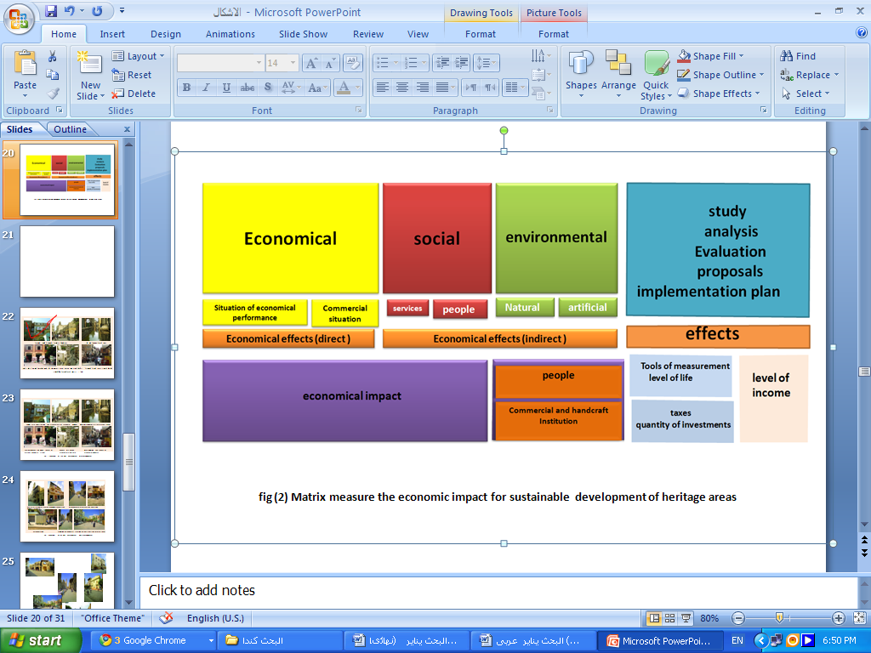**5 - Matrix measure the economic return to areas of the Architectural Heritage** Based measurement matrix yield economic zones architectural heritage on a set of procedural steps successive three pillars of sustainable development and is followed by analysis of the economic effects of direct and indirect, and phase measurement of economic returns at the level of the people through a standard indicators (income - the standard of living), businesses and crafts through a standard set of indicators (taxes - the volume of investments), as shown in fig (2)

**Fig (2) Matrix measure the economic impact for sustainable development of heritage areas**

**6 - Study for application of the Street Development Project Elmoaz street Fatimid Cairo**  By applied to the study of empirical research on the ideal study sample such as goats Street development Project as one of the leading examples of the characteristic development of heritage areas in Egypt through a series of measures are operational theory which it shown in fig (2) Matrix measure the economic impact for sustainable development of heritage areas

Based measurement matrix yield economic zones architectural heritage on a set of procedural steps successive three pillars of sustainable development and is followed by analysis of the economic effects of direct and indirect, and phase measurement of economic returns at the level of the people through a standard indicators (income - the standard of living), businesses and crafts through a standard set of indicators (taxes - the volume of investments), as shown in fig (2) By applied to the study of empirical research on the ideal study sample such as goats Street development Project as one of the leading examples of the characteristic development of heritage areas in Egypt through a series of measures are operational theory   
**6-1 General description of the study area   
Location:**   
 Area is located in Cairo historic downtown Cairo (Sector heterogeneous number "1") scheme of development long-range region of Greater Cairo east of the River Nile, which is separated by regions of the city center, Garden City, bounded to the north the old city walls and the door of poetry and the aesthetic and the south castle Zeinhom and East Street Mansourieh and the facility Nasser Street and west and the Uzbek Purcead, Abidin and the downtown area soak into the corner of Al-Azhar (east / west) and goats to Almoaz street (north / south), as shown in fig (3) and fig (4)   
Total area of the study area:

**Fig (3)Heritage buildings in El Mouaz street Fig (4)Study area in historic Cairo**

The project covers an area of 1070 acres, equivalent to 4.494 million square meters   
Population:   
-Total population in 2000 some 133 thousand people are expected to reach 105 000 people until the 2017 density of 135-150 persons / acre.   
 Street is Almoaz the main street of the city and was called the Great stalk and extends north from the door to the door Fotouh Zuweila south, and he was also a street been al kasserine Fatimid relative to the east and west.   
-Almoaz street contains on a set of the most important Islamic monuments in the beginning of the section Fotouh north and through the Mosque of the ruling abo elkar alkalaby, a mosque and the way Selehdar and Beit Sehemy Fjama Aqmar Vsepel Abdul Rahman Katakhda School Camellia Palace Bashtak Vhamam Inal Fajannagah apparent plum The Al-al-Nasir Muhammad and a group Qalawun.   
- The length Almoaz street about in 1200 meters and there are number of 103 drug (60 private sector - 11 endowments - 32 effects) and the street has 408 shops (162 shop supplies outlets - 15 shop Fragrances - 36 shop cotton products - 163 various activities - 92 place Goldsmiths It was possible to take advantage of open spaces as gathering places for cultural and commercial activities as an extension of the closed spaces as shown in fig (3) Which it can take advantage of open spaces as gathering places for economic and commercial activities and entertainment, creating a bridge between the closed spaces of the buildings and open spaces, as shown in fig (5)

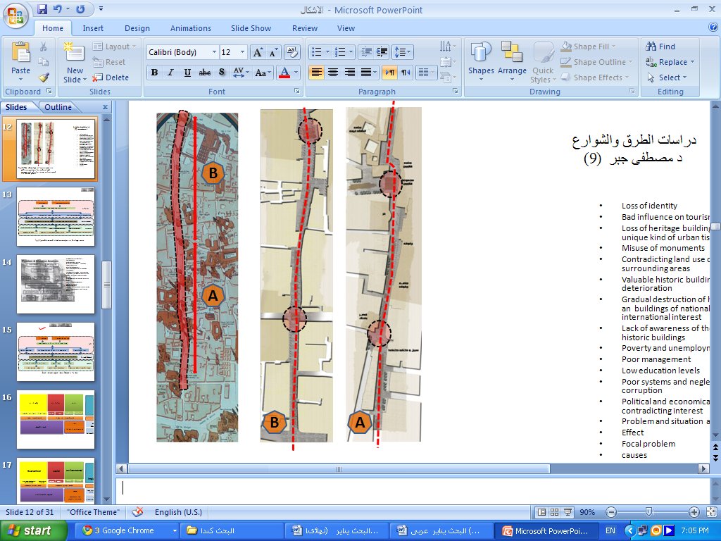

**Fig (5)Take advantage of open spaces as gathering places for cultural and commercial activities as an extension of the closed spaces**

**6-2 Street area of heritage buildings goats**  Dates from the Fatimid Cairo to the year AH 358 / AD 969, when Gouhar Sicilian ,chief Fatimid Caliph founded Almoaz to the religion of God and characterized this region Street Almoaz street Fatimid, which is the oldest streets of Islamic Cairo and contains many relics of the Islamic Fatimid era and one of the main commercial streets in Cairo and extends about 3 kilometers away from the gate Fotouh the north to the matter or to Abbas, south of Mara door Zuweila Given the importance of archaeological and heritage of that region, which contains many ancient monuments such as Koranic schools and mosques and public water fountains, such as for Mohamed Ali Palace Ghoury and inclusive the ruling of Allah, mosque Qalawun, with have a lot of effects of neglect and pollution from increased volume of activities inappropriate to the nature of the region has increased the need for the importance of preservation due to their importance architectural, archaeological and heritage, tourism and economic in addition to the historic and cultural dimension has so was the importance of preparing a comprehensive plan to upgrade them to take Almoaz street religion God Fatimid center them, while maintaining the historic character of the tracks with the development of the region and the preservation of national wealth that must be protected and there is a distinctive heritage buildings m the region are as follows

|  |  |
| --- | --- |
| Gateway Fotouh and the wall of the country - Al-Hakim Mosque - Corner of Abu good Alklebany - Mosque of Suleiman Agha Selehdar - Collector Aqmar - Yellow Path - For a book Abdel-Rahman Katakhda - Palace of Prince Bashtak - School and Mosque of Sultan full - Bath Onie | For Muhammad Ali Balnhacen - Mosque of Sultan Erfoq - Mosque of al-Nasir Muhammad - Dome School Qalawun - Remains of a school-Zahir Baybars - Remains of a school-Salih Najm al-Din - For a book Khusraw Pasha - A mosque and a way to purgatory - A mosque supervision Barsbay And so is the house of the judge, including the effects such as: 1 - Hall of loving religion 2 - One Mamay Saifi 3 - Gate alkady |

Almoaz street is the main street, established by the Fatimids of the passage of the city of Old Cairo was called Benalasrain street before that street , which was passing through parades celebrations and the covering of the Kaaba. And the street is already open-air museum if includes all the buildings of the Islamic and military and religious, social, educational, including: As shown in fig (4) (the website of the Ministry of Culture )  
Under the state's interest in Fatimid Cairo in cooperation with UNESCO in recent years, a national campaign for the maintenance and restoration of the effects of Almoaz street and the process of developing the same street to return it to the old luster, especially with the declining infrastructure of the region, poor architecture as evidenced in the fig (6)

**Fig (6 ) conditions of the built environment pre-development**

**Fig (7 ) conditions of the built environment** post-development

While we find that after the completion of the development of infrastructure and facilities all began to develop the street from the gate Fotouh and even the intersection of Al-Azhar and a length of 1400 meters in 1/3/2009 at a cost of three and 20 million pounds which takes into account a range of business are as follows:   
1 - Development of all facades of houses and shops on both sides of the street.   
2 - paving the street with ground black granite Aswani local (seven thousand five hundred square meters)   
3 - Action coral squares with granite Gandula (four thousand nine hundred square meters)   
4 - work blocks granite Gandula (two thousand and nine hundred linear meters)   
5 - The street lighting lanterns and cantilevers specially manufactured to the old-fashioned classic, which is consistent with the age effects found by   
6 - have also been developed lanterns buried curbs and lighting directed on the walls of impact and to demonstrate aesthetic   
7 - The control the movement of cars enter the work of the electronic gates and has been placed on all the roads leading to the street and shut down from nine in the morning until nine pm at a cost of three and a half million pounds in order to give opportunities for pedestrians and tourists to the movement with ease and enjoyment of watching the effects of existing street.   
He also asked the shop owners to change their activities in line with the nature of the archaeological to the place and the necessary tourists buy it and his vision has been developed courtyard judge and the establishment of the cafeteria to provide services to tourists, making the Ministry of Culture to pay attention to the rest of the region and is a detailed study of a comprehensive development process for the whole region (website of the Ministry of  **6-3 Development partners to Street Development Project goats Fatimid Cairo Culture**  Thus, popular participation is an essential in the process of rehabilitation of areas, heritage or historic cities in Article twenty-seventh of the World Heritage Convention to "the need to strengthen appreciation and respect for cultural heritage and to notify the population and explain to them by all means to threats to cultural heritage and activities by the state in that area and the role that people have to do. "   
We must not forget the role of NGOs in the region is closest in contact with the population and education, as well as encouraging businessmen to invest in tourism, employment and re-appropriate use of historic buildings and archaeological sites in Cairo, the historic way that is consistent with systems and methods of conventional construction and to ensure that specific criteria laid down by the authorities responsible for cultural heritage, which prevents degradation in the future   
 A joint working group between the ministries, such as the Ministries of Awqaf and the Ministry of Housing and Construction and Maspgm the local and the Ministry of Communications, Ministry of Interior, together with the Governorate of Cairo, and the Committee under the leadership of the Ministry of Culture, who was entrusted with the task of developing an action plan and assign tasks to those responsible in the development of the street   
 First: Cairo Executive:   
Project was implemented to improve sanitation, water, electricity, telephones Almoaz street adoption of 5 million through sponsorship of the Chamber of Tourism, was carried by the device Cairo Executive sanitation project in coordination with other agencies for facilities and described as follows: -   
The completion of all sewerage works project.-  
- The lifting of the water line up from the intersection of St. El Khouronfosh until the intersection of Prince of armies.  
- Sub-links has been improved "water - Telephones" in this region.  
- The completion of the installation of water main line along 200 meters from the chapel-Azhar Street  
- The work of a number (2) Telephones room floor at the same distance from Alsnadeghip area until the intersection of Al-Azhar.   
 This work was carried out in three stages along the street: -   
  Phase one: first phase was set Qalawun Street Prince armies length of 300 meters   
  Phase two : was the Amir of the armies even Fotouh gate length of 600 meters   
  Phase three : from a disease has been Qalawun Street Al-Azhar. Second: The Ministry of Culture   
     The Supreme Council of Antiquities the work of the re-establishment of the origin of the coordination work of the archaeological and architectural lighting and a comprehensive paving basalt and granite paving sidewalks, landscaping and coordination of architectural facades real estate. Third: Downtown Cairo   
 The neighborhood agreement on the transfer of wholesale onion, garlic, olives, lemon and the 47 place to be transported to market transit and remain shops Almoaz street belong to them, provided that the activity in line with the development that is in the street as well as the traditional activities of multi-Almoaz street, have been reduced levels all stores Almoaz street, according to the new street level.   
 There Was a number 13 gates on all the side streets on the Almoaz street to regulate traffic on the street, as agreed with the General Directorate of Traffic by the device.   
  Currently under study a piece of land for the establishment of a security complex (Civil Defense and Fire - Ambulance - Tourism - security and password) to control the street was also provided a number 3 Baths Tourist Almoaz street to serve the citizens and tourists (Mohamed Awad, "Patrimonies partag'es en m'editerran ' ee ", EUROMED Heritage II)        
 **6-4 bases of the idea of planning development process**   
 Based foundations for the idea of planning the development process on a set of key points, namely:   
Planning adopted the idea to:   
• develop a blueprint to develop and promote the region to revive the region and make it lured Tours by identifying priority projects to upgrade in order to protect and restore historic buildings and the protection of the urban fabric of traditional and improve the urban and urban area and remove clogged kinds especially on historic buildings and campus.   
• Customize Street Almoaz Fatimid pedestrian only.   
• disrupting the surrounding areas Almoaz street and effects of the population and activities inappropriate to create areas of heritage tourism characteristic activities and crafts.   
• Maintain corridors of antiquities and historical dimension of roads and development.   
• Customize the central regions for each of the corner of Al-Azhar and Almoaz pedestrian and open areas.   
• Create ways to Favorite parallel nature as possible to a street defined transmission mechanism of the passage beyond.   
• maintain a network of roads and lanes of existing and distinctive style and consistent with the customs and traditions of the population.   
• evacuate the area of residential uses and converted to uses archaeological, tourist and commercial tourism in the historical heart of the region Major uses of land:   
Has been divided into the region's main uses:   
• Services 13% area of 139.1 acres   
• 18% road area of 192.6 acres   
• 49% of the residential area of 524.3 acres   
• 20% of the tourist area of 214 acres   
Implemented plan for the development of Almoaz street  
 First: - Infrastructure: -   
  -    It has been completed of all sewerage works in the street like  water line which it was raised up from the intersection of El Khouronfosh until the intersection of Prince Street armies.   
   - There  are works of the Sub-links "Water - Telephones."   Completed the installation of the main line of water along 200 meters from the chapel Street Al-Azhar.   
  - The work of a number (2) Telephones room floor.   
 -   It was completed to change the infrastructure Almoaz street "sanitation - electricity - water systems - Telephones."."   
    -  Street level has been reduced from the first full victory until the gate of the intersection of goats with Al-Azhar Street, as well as some side streets of Almoaz street   
      Restoration has been completed and the property fronts a street, the field house of the judge as well as the facades of some shops. The paving of street was completed from the judge square to the judge Road House. -  
-  The executive body for drinking water projects and sanitation in Cairo, the Ministry of Housing to finalize the project to improve sanitation Fatimid Cairo archaeological areas "algamalia / algoura / Mansourieh" total area of 725 acres.   
-  Project work has been improving water Wall area of ancient Egypt at an estimated cost 7 million pounds in addition to addressing the problem of groundwater, which was threatening the wall.   
      It has been completed to develop the field of al-Husayn and street scene Husseini, where the development of infrastructure for sewage, paving, restoration and establishment of gardens, fences, sidewalks, granite and lighting columns, decorative and has been the development of the field of six Fatima, the Prophet where he was working to expand and create a garden in the field was re-paving    -   The Project work has been sound and light system to show the effects of that street in the best picture.  
   -    Lanterns have been installed for street lighting and to complete that system was shut down the street to traffic at certain times will be from 8 am until 8 pm for pedestrians only, as shown in fig (8) (Office of the province - a project the development of Almoaz street religion and upgrading - Cairo historical even 2017 - Cairo)  
Three electronic toilets have been installed for street to serve the tourism activities in the street-

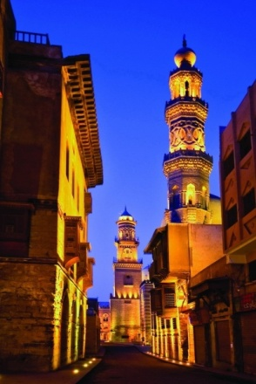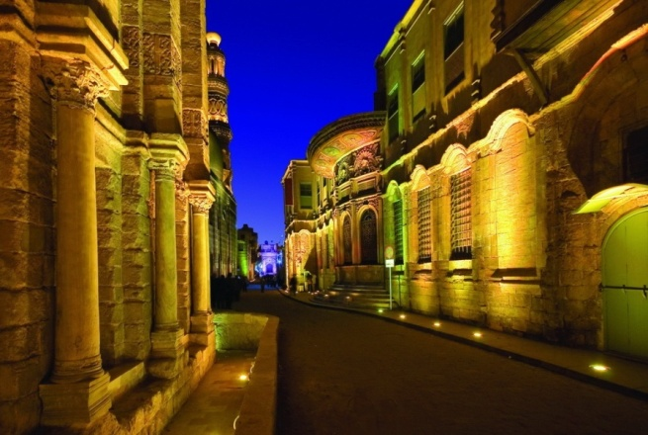

**Fig (8) exterior lighting of buildings, including heritage given to painting three-dimensional concrete**  Second: the shops and markets: -  
      Floor level has been reduced all the shops according to a new level of the street. wholesale onion, garlic, olives, lemon and number (47) Were transferred and they were taken to replace the jumper on the market to remain street shops goats belong to them, provided that the activity in line with the development that has been in the street.   
  third - For Real Estate: -   
 An ongoing presentation of a proposal for the complex police and the planned street. Interfaces have been developed and real estate Street Almoaz street Fatimid period The establishment of a number (13) portal to all the side streets on u Almoaz street to regulate traffic on the street in accordance with the instructions of the traffic department.   
**6-5 goals laid out for the process of development**   
 Confined to strategic goals for the project development process Almoaz street in set of goals for the region itself (Almoaz street - Historic Cairo) and targets of the mother city (Cairo)   
6-5-1 goals for the region (ST goats - Historic Cairo)   
- Support and develop infrastructure and facilities to ensure the preservation of the physical character, archaeological   
- Distinctive architectural renovation of buildings and re-employment to serve the region   
- in order to elevate the social and economic for the people of the region   
- Activate the recreational activity tourism and support services and tourist facilities   
- Revitalization of the region culturally and rally to make it a cultural center that serves the people of the region 6-5-2 targets in Cairo Governorate  
- Add the path of tourist services is available in a special occasion - slum upgrading and slum improvement of the restoration of Cairo - improving the infrastructure areas and modesty Old  
 **6-6 Theoretical and applied analysis of the draft study** This set contains several items **:**  
- The transfer of polluting activities of small-scale industries to the ancient neighborhoods outside Cairo to improve the environment.  
- Add a tourist area characteristic of the tourist map of Cairo  
- Stimulate public awareness of the cultural city of Cairo and the addition of a cultural center open  
- To improve the social conditions of people in popular and packed the crowded slums and support facilities and infrastructure and services

**Fig (9) theoretical applicable analysis of case study**

 6-6-1 determinants of theoretical analysis (problems - solutions)   
     Confined to the determinants of theoretical analysis in the study of the most important problems documented in the data and official documents or research and study of the solutions the theory of the study and analysis and produce a set of suggestions and solutions executable field through the study of the built environment Almoaz street and analysis of its basic elements, including determine the movements of the improvement and development

**Fig ( 10) Classification of built environment in El Mouaz street**

First: the most important problems documented in the data and official documents or research  
- Densely populated for the people of the region, where up to 105 thousand people until 2017 density of 135-150 persons / acre..  
- Low level of services and infrastructure and their impact on heritage buildings in the region  
- Low living conditions and social development of the region's population  
- Bad case of construction of residential buildings, workshops, adjacent to the historic buildings, heritage  
Second: the most important solutions proposed by the theory and reality of data and official documents  
- The unloading of the population of the region to other parts of alternative  
- Expansion of the streets and set up facilities and new infrastructure  
The establishment of social units and community service centers to raise the living conditions and social development of the region's population The demolition of houses with a status of construction low We note that the determinants of the former is based on the theoretical perspective in the compilation of information and analysis without relying on the interactive field study   
6-6-2 determinants of Applied Analysis (Problems - Solutions - effects)   
Confined to the determinants of analysis applied to the study of the main problems affecting the central region (enterprises - the people), record and query of questions of the living conditions and social and propose feasible solutions for the field, depending on the study and careful analysis of the natural all origins and determinants of spatial him (nearby buildings - the infrastructure - the architectural style …….ect ) and social analysis of the families, according to the circumstances of each family and relationship are central to the mutual   
   **6-7 the economic status of goats Street area before the development stage** This stage contains four steps :  
First: commercial activities   
Most of the activities were traded spice trade gifts and crafts copper and fabrics, equipment and supplies coffee shops, jewelry and gold and silver jewelry and ornaments   
Second: craft activities   
Character or copper weaving and crafts   
Third: The social and economic situation   
Social conditions for most poor families, mostly with simple jobs and the incomes are low with the exception of the owners of shops and workshops   
Fourth: the educational level   
Majority of the population have a low educational level and the great generation of parents uneducated while the younger generation: most learners average education and a few higher education   
**6-8 the economic status of goats Street area after the development phase** which it divided into several points:  
-Desired goal of the Street Development goats :   
• emphasis on maintaining uses of direct economic benefit to serve tourism.   
• Increase the craft activities for non-contaminated with a commercial product, tourism to increase employment opportunities. - Added business activities   
Trade, made of leather and embroidered fabrics, mobile phones and electrical appliances   
- Craft activities added   
Industry, made of leather and cloth embroidered   
- The development of social and economic situation   
Recovery of social and economic situation represented in the grocery stores, goods imported and distinctive shops and mobile appliances and Bicycle and Altotoc and cars  
- Educational level   
Privacy centers lessons and computer-education centers and language centers and repair of electrical equipment in particular the Center delegation to community service as evidenced in fig (11) and it can be determined by the manifestations of high economic returns of the draft study by the target groups and the people are class 0 people of the area) and enterprise-class commercial and craft (shops - workshops -)

**Fig (11) business activities and crafts added goats Street area after the development**  **6-9 measure the economic return of the draft study** Measure the economic output of the project study (Almoaz street) through the application of vocabulary of the field study data and use the matrix of the proposed standard for measuring the economic return on the development of goats Street area of various stages and measuring the resulting economic impacts (direct - indirect) 6-9-1 measuring the economic returns to the people   
To measure the economic return to the people is by measuring the level of human comfort as a ruler and a key for hydration sustainable (environmentally - social - economic)

**Table (1) Measuring tools Comfort humanitarian**

|  |  |  |  |
| --- | --- | --- | --- |
| Socially | Economically | Environmentally | Comfort humanitarian hubs  Measuring tools Comfort humanitarian |
| -Improve the quality of food and clothing -The presence of private cars | -Improve the level of income and expenditure levels | -Improvement in the environment healthy | A flat income |
| -High level of education  -Limited and low level crime | -Increase sales and purchases | -Improved health conditions -Improved environmental visual -High level reconstruction of the people | Level of living |

6-9-2 measuring the economic returns of enterprises and craft   
To measure the economic returns of enterprises and craft is through a measure of the overall sustainable development of enterprises within the region

**Table (2) Measuring the economic returns of enterprises and craft**

|  |  |  |  |
| --- | --- | --- | --- |
| Socially | Economically | Environmentally | Axes of overall sustainable development    Measure the overall development tools |
| Improvement and development of the social conditions of workers and craftsmen from non-residents of the region | Increase the volume of commercial activity, traders and owners of workshops | -Improved environmental visual | Size and rate of investment (institutions) |
| Improve the social conditions of the region through the allocation of specific budget | resources for overall development | -For resources to improve infrastructure and maintenance | Tax collections and government (the State) Electricity Gas Water Telephone |

**Fig (12 ) System measuring the economic return on the sustainable development of heritage**

**Fig (13 ) Sectors of development proposed for the development of the built environment of streets and public services and facilities**

**7 - Conclusions and recommendations   
7-1 results:**   
1 - the economy a major factor in urban planning studies for areas of heritage tourism in order to benefit the maximum value from their development, and development and the creation of economic value that is supportive of an area on the level of communities, and the heritage buildings. 2 - Traditional areas of nature tourism need to raise the level of services and facilities and infrastructure, improving living conditions and give a better picture of the population because they are a key component of the region and constitutes the distinctive character of heritage.  
3 - Work to create areas of new housing for residents of the areas adjacent to the traditional heritage area, which could take advantage of the old residential areas either substitution or replacement of the terms of use or function.  
4 - Almoaz street need to association system of activities and uses are compatible with the level of social, economic and directed towards activities with economic value is useful to the people of the region compatible with the character, such as traditional (copper work - the work of fabric)  
5- Almoaz street need service activities consistent with the nature tourism heritage represented in the communication centers, hotels and restaurants to serve tourists distinctive visitors.  
6 - Almoaz street need the services of its facilities and upgrade facilities, infrastructure, and use of meaningful employment hub for the historic Cairo and the development of areas adjacent right and left for development, creating a space additives.  
7 - Attention to activities and uses of nature, daycare and evening stage to support and develop an area of common goats future which creates life and movement within the region to maintain effective communication. **7-2 Recommendations:** 1 - the traditional areas of support through a uniform consisting of those with scientific (Culture - Tourism - Housing - local government) to coordinate and unify the efforts in a manner consistent with the circumstances surrounding the region.  
2 - Promote heritage tourism through the definition of heritage areas locally, regionally and internationally through fliers and informative tourist 3 - Establishing a link between the center of the two constituent Almoaz street in the form of a tunnel to make communication between the two parts.   
4 - Replacement and replace activities and uses non-compatible with the heritage character of the area.   
5 - packed slums surrounding the area.   
6 - Convert the surrounding area to support the pedestrian tourism and business activities inherent to it especially the region including the Red Path occurs an increase in economic returns to the country. **REFERENCES** -Gabr, Moustafa ,Dar Al-Omran Architecture and Planning,2006 ,"Study of the Street Development goats" .   
-General Organization for Physical Planning development, 2008, " plan for the provinces of the Republic: Map of Cairo Governorate. -Ministry of Culture , 2002 , Architectural Study of Historic Cairo, Egypt.   
-Hesham, Eman ," Delimitation of Borders of the Historic Cairo ,cairo,2007, "Luxor Heritage Cities Conference, organized by the Ministry of Housing and facilities. -Mohamed Awad, "Patrimonies partag'es en m'editerran'ee, Alexandria , 2008 ," EUROMED Heritage II -Study Development Elmoaz street Cairo , The Ministry of Culture. http://www.ecm.gov.eg , (accessed 13May , 2010). - General Organization for Physical Planning development , 2008, "The Office of the province - a project the development of the Almoaz street Fatimid and upgrading - even historical Cairo in 2017"

-National Organizing of Urban Harmony , 2010,"[Law of the organization of demolition of Buildings and facilities not doomed to fall and preservation of architectural Heritage](http://www.urbanharmony.org/en/rule%20144%20for%202006.pdf) .